Accomplishments

# Sprint 1

* Created the base ERD
* 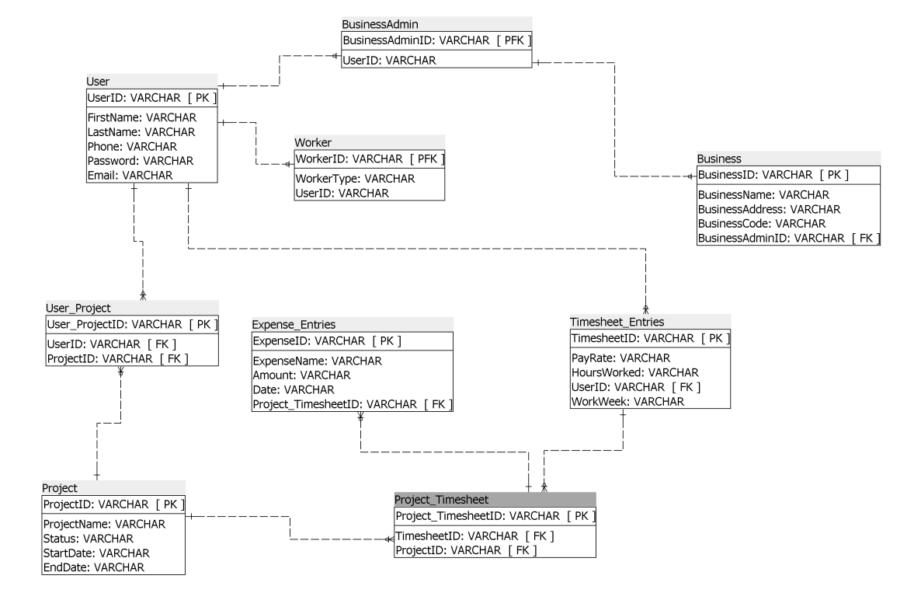
* I was having issues figuring out the email verification, but with Nunj’s help, we were able to figure it out (reference my branch).
* Working on some front-end (reference my branch)
* A lot of Research
  + <https://docs.microsoft.com/en-us/aspnet/core/security/authentication/accconfirm?view=aspnetcore-3.1&tabs=visual-studio>
  + <https://docs.microsoft.com/en-us/aspnet/mvc/overview/security/create-an-aspnet-mvc-5-web-app-with-email-confirmation-and-password-reset>
  + <https://tutorials.visualstudio.com/aspnet-azure/create>
  + <https://tutorials.visualstudio.com/aspnet-azure/publish>
  + <https://docs.microsoft.com/en-ca/azure/>
  + <https://www.c-sharpcorner.com/article/how-to-deploy-web-app-to-azure-using-visual-studio/>
  + <https://tutorials.visualstudio.com/aspnet-azure/create>
  + <https://tutorials.visualstudio.com/aspnet-azure/publish>
  + <https://www.youtube.com/watch?v=3AYoipyqOkQ&list=PL6n9fhu94yhXQS_p1i-HLIftB9Y7Vnxlo>
  + <https://www.w3schools.com/>
  + <https://clockify.me/dcaa-compliance>
* Collaboration over Discord.

# Sprint 2

* Worked on a lot of project documentation (GrizzTime_Documentation). I set up it up on google drive and I’m working on completing it.
  + Within the documentation, I reviewed the project vision and the tools and technology we will need. I also reviewed our plan for each sprint.
* Helped with the sprint presentation
* Tried to help with getting a database server running, but I was having issues. With Misael’s help, the Azure server was set up.
* More research
  + <https://docs.microsoft.com/en-us/visualstudio/data-tools/add-new-connections?view=vs-2019>
  + <https://www.youtube.com/watch?v=p7X8lH_XMtI&t=7s>
  + <https://www.youtube.com/watch?v=BgvEOkcR0Wk>
  + <https://docs.microsoft.com/en-us/azure/devops/organizations/projects/connect-to-projects?view=azure-devops&tabs=visual-studio-2019>
  + <https://docs.microsoft.com/en-us/azure/sql-database/sql-database-connect-query-dotnet-visual-studio>
* For documentation
  + <https://www.projectmanagement.com/wikis/233055/Gap-Analysis>
  + <https://www.citizing-consulting.com/en/expertises/social-eco-audit/>
  + <https://www.dominionsystems.com/blog/the-risk-of-using-paper-time-cards-how-to-replace-them>
* Continuing to Learn front-end development.
  + <https://www.w3schools.com/>

# Sprint 3

# Sprint 4

# Sprint 5

# Sprint 6